  
**McAllen MRI Center**  
320 North McColl Rd. E  
McAllen, TX 78501  
Phone: (956)-687-9636 Fax: (956)-687-9743

------------------------------------------------------------------------------------------------------------  
**NAME:** Allan Kap **Date of Exam:** 04/01/92  
**DOB:** 01/05/50 **Medical Record:** 1231  
**Referral Dr:** Mario   
**Procedure:** SOMETHING  
  
**History:**   
  
------------------------------------------------------------------------------------------------------------

Thank you for your referral  
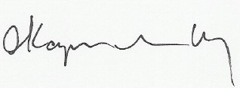  
Electronically signed by:  
Allan Kapilivsky M.D.  
Reviewed and dictated the same day